assignment-b

Mongo db

Question-1-Create a database named university and a collection named students. Insert multiple student documents with fields: name, age, department, and grades.

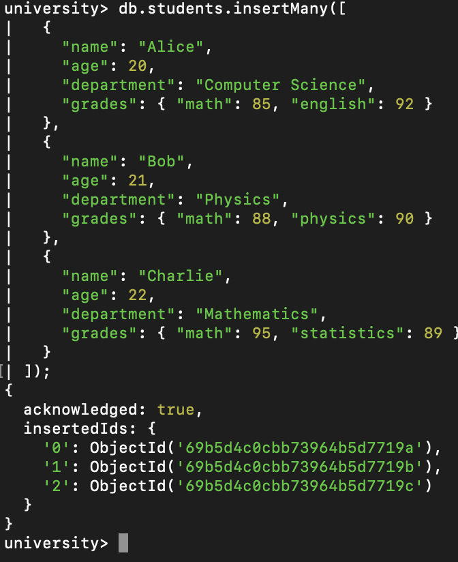

Question-2-Write a query to display all students who are in the Computer Science department.

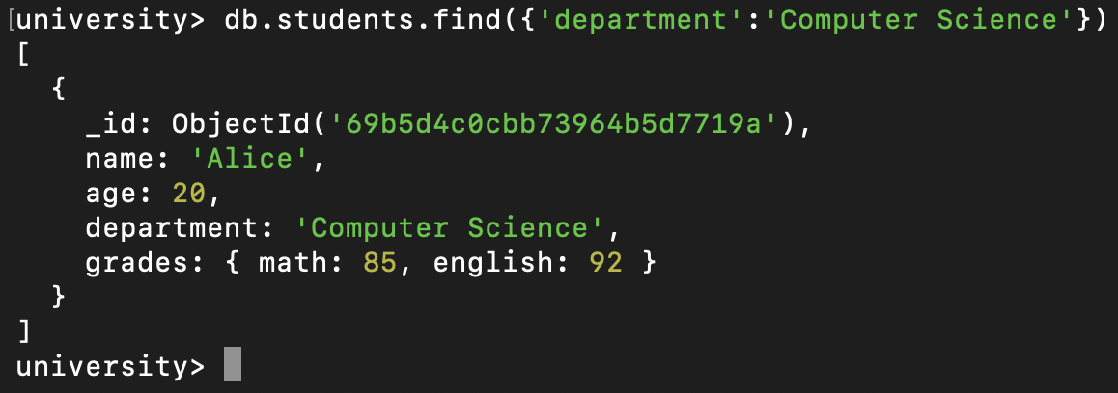
Question-3-Write a query to update the grades of a student named Alice by adding a new subject programming with a grade of 93.
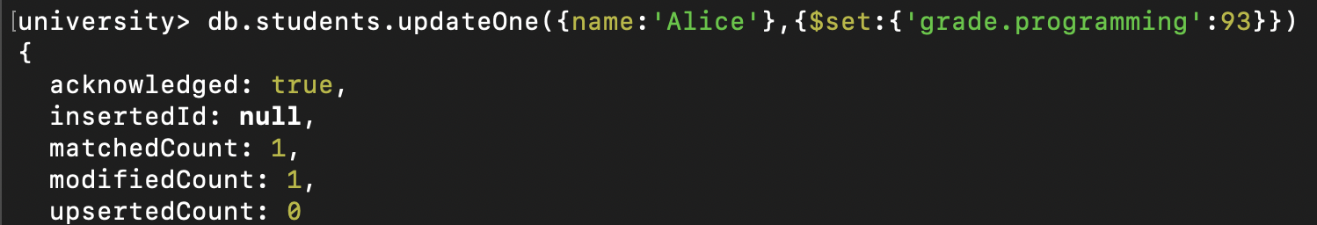
Question-4-Write a query to increment the age of all students by 1.
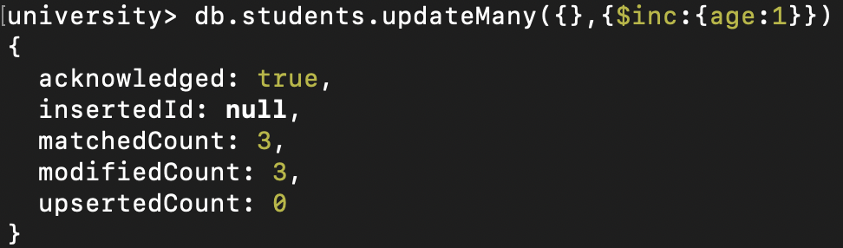
Question-5-Write a query to delete all students who are 23 years old.
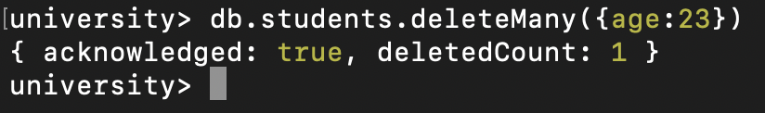
Question-6-Write a query to create an index on the name field of the students collection.
Ans :Topic not covered

Question-7-Write an aggregation query to group students by their department and calculate the average age in each department.
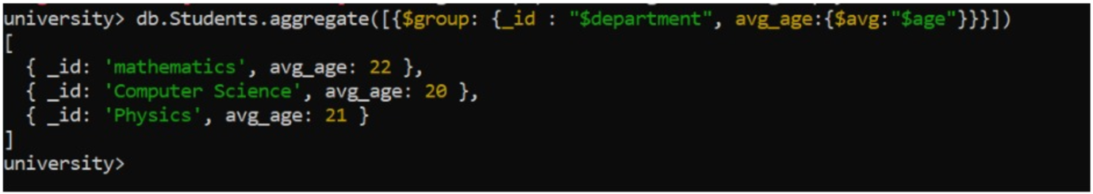
Question-8-Write a query to find all students who have scored more than 90 in any subject.
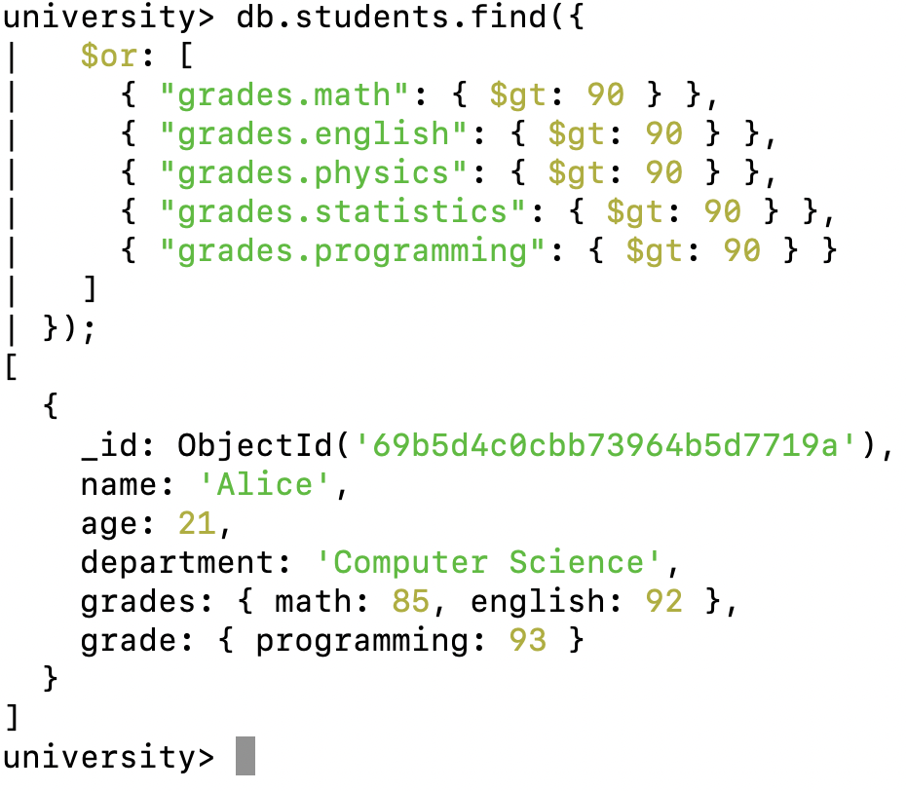

Question-9-Write a query to add a new field graduated set to false for all students who are in the Mathematics department.
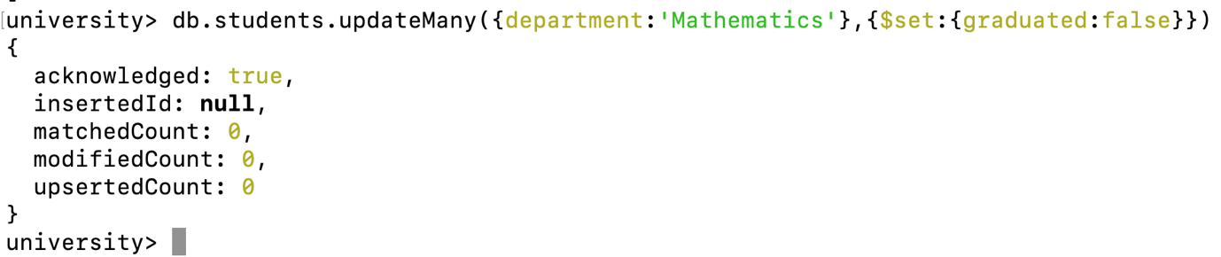

Question-10-How can you retrieve only the name and department fields for all students, excluding the _id field?

